PATCHING RESOURCE

- Edit RestaurantsController.cs
  - Add patching method
- Create 3 files in Restaurants.Application/Restaurants/Commands/UpdateRestaurant\
  - UpdateRestaurantCommand.cs
  - UpdateRestaurantCommandHandler.cs
  - UpdateRestaurantCommandValidator.cs
- Edit UpdateRestaurantCommand.cs file
  - Create properties that we want to patch
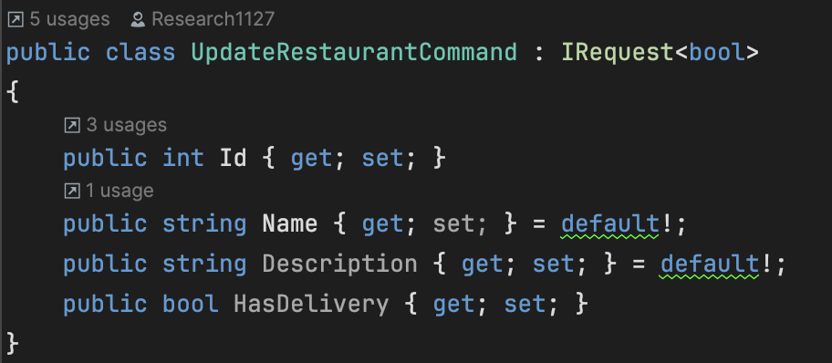
- Edit UpdateRestaurantCommandHandler.cs
  - Create the business logic to patch the data
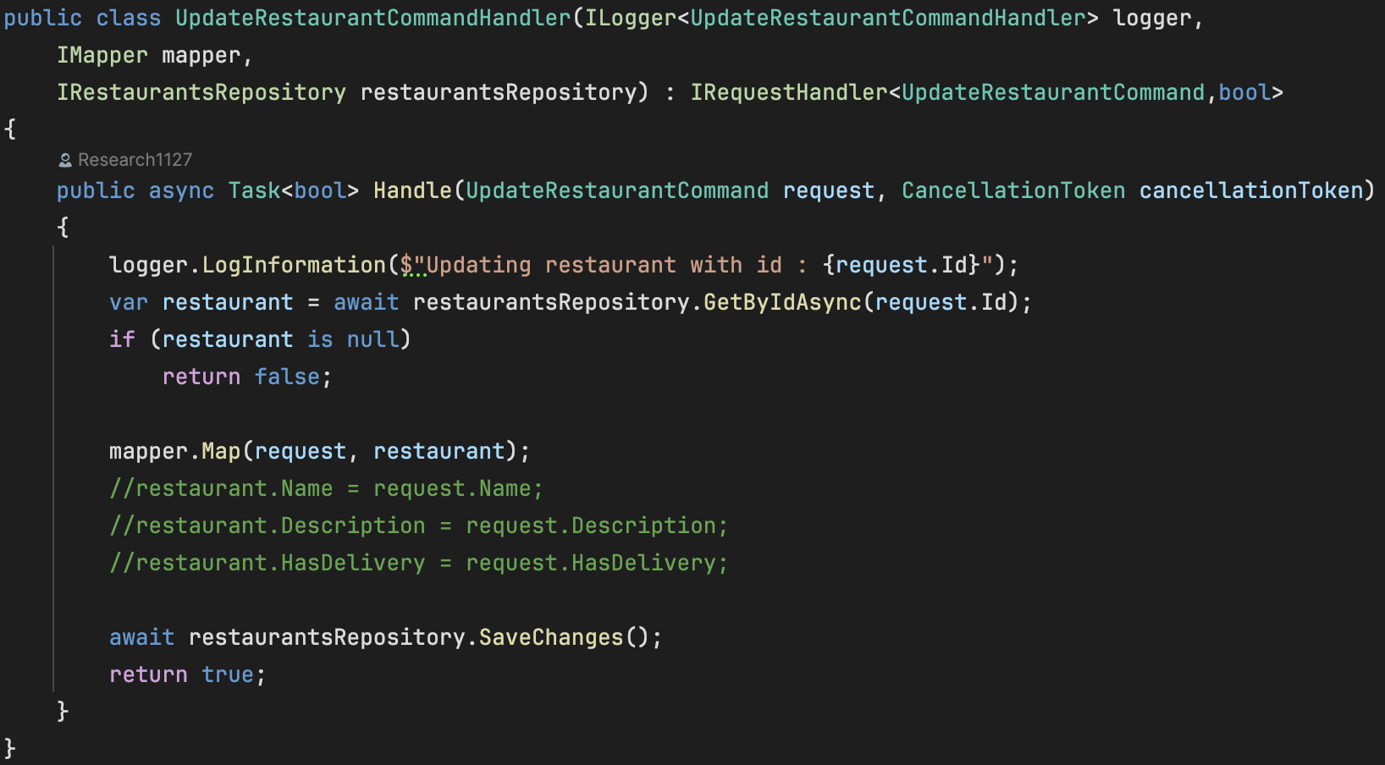
- Edit IRestaurantsRepository.cs
  - Add Task to save the changes
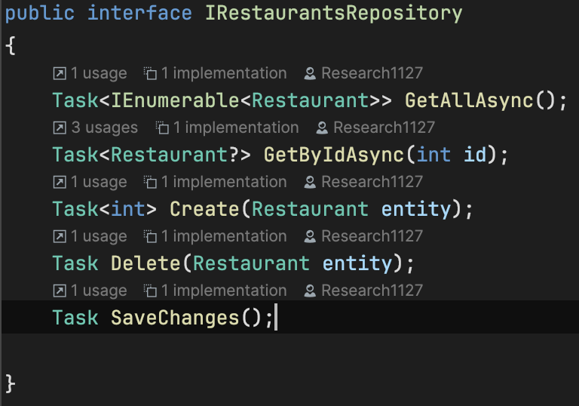

- Edit RestaurantsRepository.cs
  - Implement SaveChanges() method
  - No curly bracket because we just want to save changes and not return anything
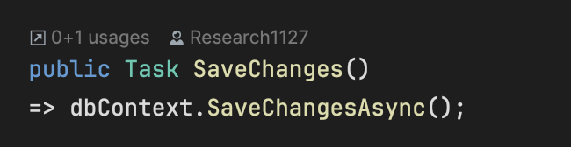
- Edit UpdateRestaurantCommandValidator.cs
  - Create rule for validating the data
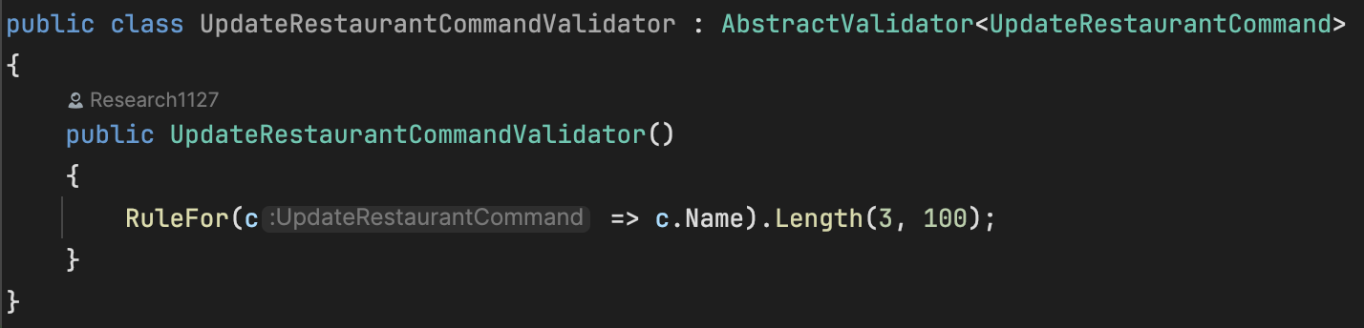
- Because we use fluent validation, we need to edit RestaurantsProfile.cs
- Finally, we need to add the endpoint in the Restaurants.Api.http
- Use Swagger to test.

